…………………………………………………..

Write the time under the clock, then find the time in the word-search

and the mysterious questions.

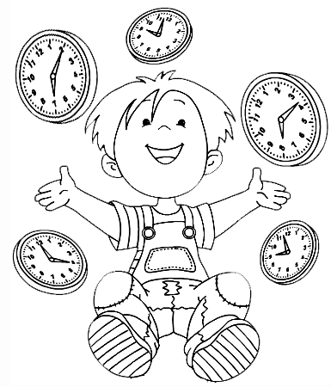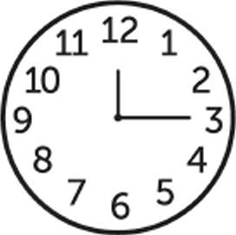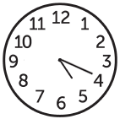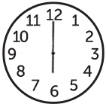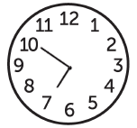

…………………………………………………..

…………………………………………………..

…………………………………………………..

…………………………………………………..

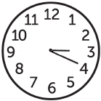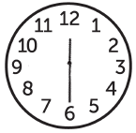

T F W H A T T E E R H T O T N E T H E

W O I M E D O Y K C O L C O X I S A V

E U T W E N T Y P A S T T H R E E L I

N R O U T E N T O S E V E N W A K F F

T O E E I G H T O C L O C K U P A P T

Y C N E V I F T S A P F L A H D W A S

P L F I V E P A S T E L E V E N H S A

A O A T T I T H G I E O T N E T M T P

S C T W E N T Y F I V E T O O N E E Y

T K E N E V E S O T R E T R A U Q L T

S D E N I N O T E V I F O Y O U G E N

I T W E N T Y T O F O U R O T O B V E

X E H A L F P A S T T W E L V E D E W

Q U A R T E R P A S T T W E L V E N T

…………………………………………………..

…………………………………………………..

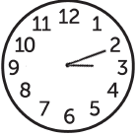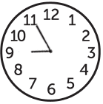

…………………………………………………..

…………………………………………………..

…………………………………………………..

…………………………………………………..

…………………………………………………..

…………………………………………………..

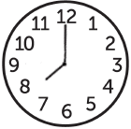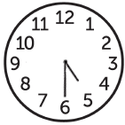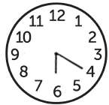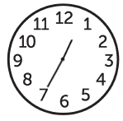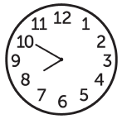

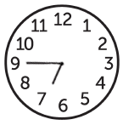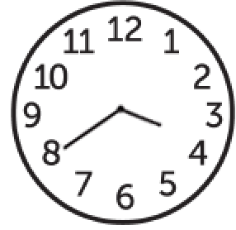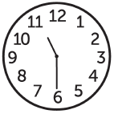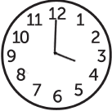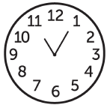

…………………………………………………..

…………………………………………………..

…………………………………………………..

…………………………………………………..

…………………………………………………..

© maestra Chiara



KEY

Twenty past five

Ten to seven

SIX o’clock

Quarter past

twelve



T F W H A T T E E R H T O T N E T H E

W O I M E D O Y K C O L C O X I S A V

E U T W E N T Y P A S T T H R E E L I

N R O U T E N T O S E V E N W A K F F

T O E E I G H T O C L O C K U P A P T

Y C N E V I F T S A P F L A H D W A S

P L F I V E P A S T E L E V E N H S A

A O A T T I T H G I E O T N E T M T P

S C T W E N T Y F I V E T O O N E E Y

T K E N E V E S O T R E T R A U Q L T

S D E N I N O T E V I F O Y O U G E N

I T W E N T Y T O F O U R O T O B V E

X E H A L F P A S T T W E L V E D E W

Q U A R T E R P A S T T W E L V E N T

Half past twelve

Twenty past three



***The mysterious questions are:***

What time do you wake up and what time do you go to bed?

Half past eleven

FIVE past ELEVEN

Four o’clock

Quarter to seven

Twenty to four

Twenty past six

Twenty-five

to one

TEN TO EIGHT

Eight o’clock

Half past five

Ten past three

Five to nine