It’s the year 1605.
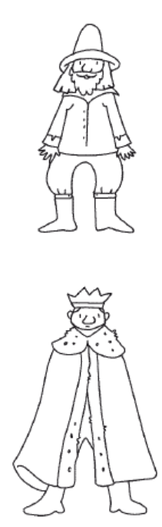

A Catholic called Guy Fawkes and his friends try to kill the Protestant King James I. They want to blow up the
with the King and his
Houses of Parliament
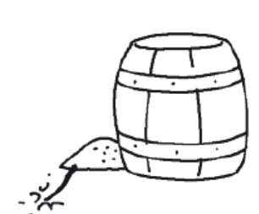
ministers inside.
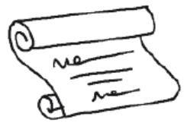
They put a lot of gunpowder in the cellars of the building.
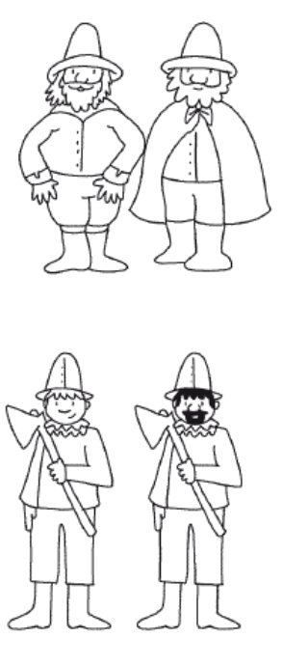
But the King receives an anonymous letter and his soldiers

arrest Guy Fawkes. He is executed.
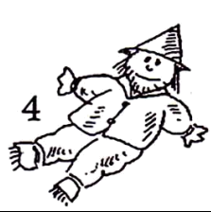
Every year, on November 5th, in England people
commemorate Guy Fawkes. Children make puppets with old
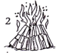
clothes and ask “a penny for the guy”. In the evening the puppets are
burnt in bonfires and people look at fireworks.
Now learn the rhyme
Remember, remember
the fifth of November
Gunpowder,
treason and plot.
We see no reason
why gunpowder treason
should ever be forgot.

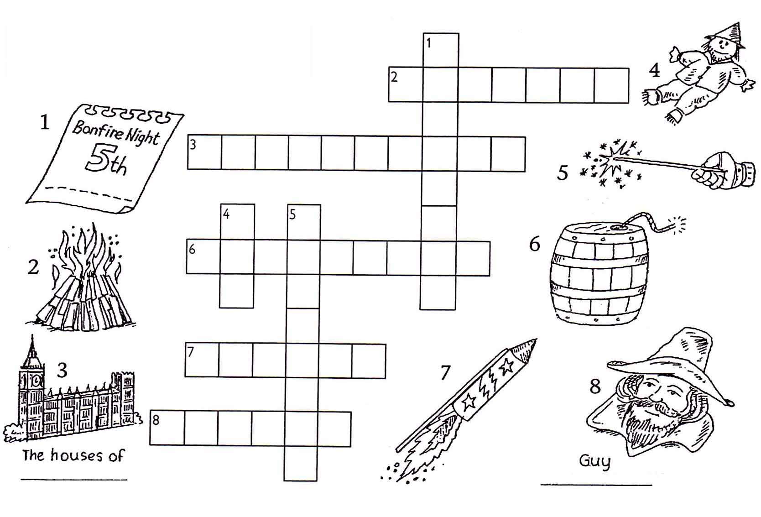
Complete the crossword

