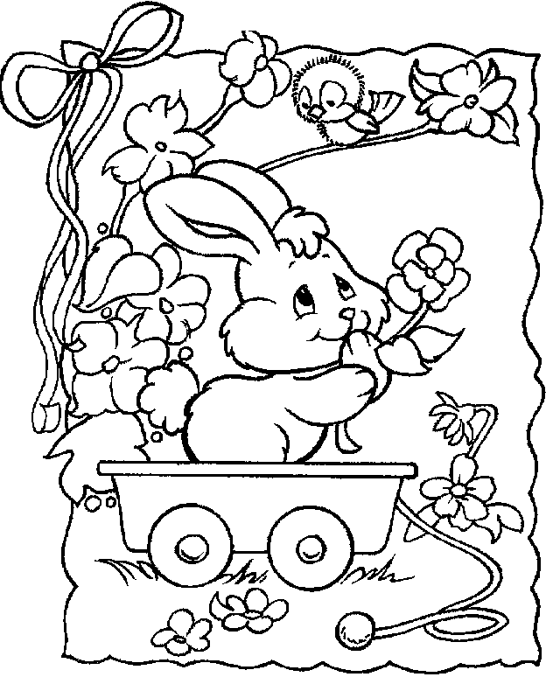
Happy Easter

_____________________________________

_____________________________________

_____________________________________

_____________________________________

_____________________________________

_____________________________________

_____________________________________

_____________________________________

_____________________________________

