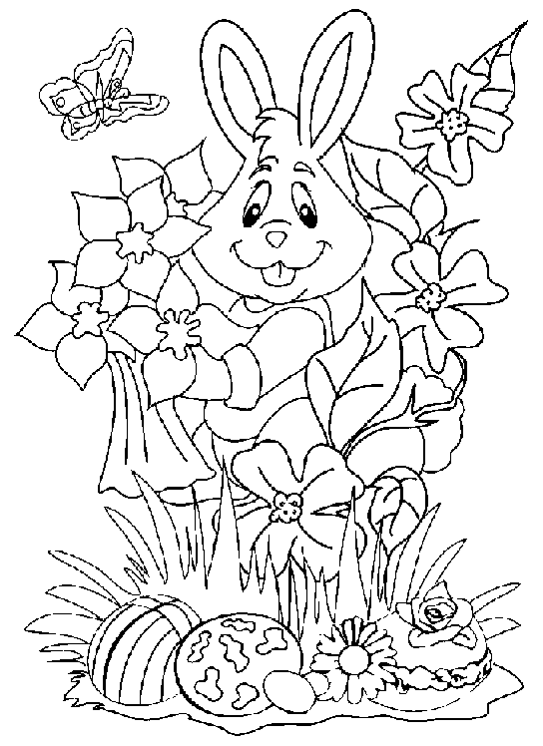
Happy Easter

__________________________________

__________________________________

__________________________________

__________________________________

__________________________________

__________________________________

__________________________________

__________________________________

__________________________________

