Make a pop up Christmas card

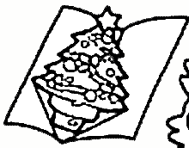

What you need:

Photocopy of a
Christmas tree
Card (A4)
Colouring pens
Glue
Scissors

Instructions:

• Fold the A4 card in half.
• Cut out and colour the Christmas trees.
• Fold the corners left and right up.
• Them fold the Christmas tree in half.
• Glue the corners and stick them on the card so the tree pops up when the card is opened.



